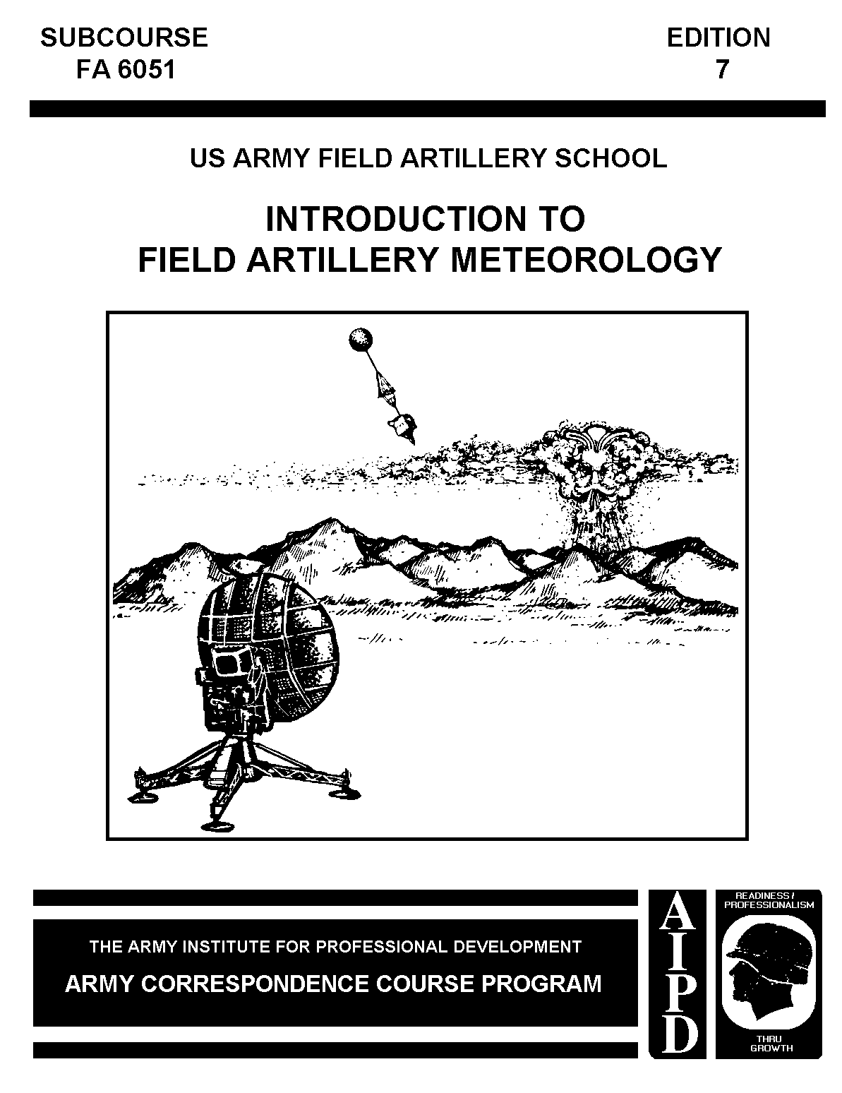

FIELD ARTILLERY METEOROLOGICAL CREW MEMBER
MOS 93F

INTRODUCTION TO FIELD ARTILLERY METEOROLOGY

SUBCOURSE FA 6051

US Army Field Artillery School
Fort Sill, Oklahoma

EDITION 7
4 CREDIT HOURS

This subcourse is designed to train the skills necessary for performing tasks related to the identification of weather phenomena, weather effects upon artillery missions, and met section equipment. This subcourse is presented in two
lessons, each lesson corresponding to a terminal objective supporting the following:

LESSON 1: Identify principal factors that produce our weather, the ballistic meteorological problem, and proper procedures to solve this
problem.

LESSON 2: Identify the organization, mission, equipment, and employment of the field artillery meteorological section.

TASK NO: None. This subcourse is introductory to basic field artillery meteorology skills and does not address any specific soldier's manual MOS 93F tasks.

TABLE OF CONTENTS

TABLE OF CONTENTS

Lesson 1: Weather and Its Effects on the Artillery

Introduction

Weather Variables

Atmospheric Structure

Dew Point

Clouds

Frontal Weather

Ballistic Quantities

Ballistic Effects

Summary

Lesson 2: Artillery Meteorological Section

Introduction

Missions

Zone Structure

Ballistic Met Message

Computer Met Message

Sound Ranging Met Message

Met Section Organization

Met Section Equipment

Capabilities of the Electronic Section

Employment of Met Sections

Summary

EXAMINATION

Lesson 1
WEATHER AND ITS EFFECTS ON THE ARTILLERY

OBJECTIVE

Identify principal factors that produce our weather, the ballistic meteorological (met) problem, and the proper procedures to solve this problem.

REFERENCES

This lesson is based on FM 6-15 and other materials approved for US Army field artillery instructions. However, development and progress render the text continually subject to change. Therefore, base your examination answers on material presented in this lesson rather than on individual or unit experience.

1. INTRODUCTION. Weather has a very large effect on the conduct of military operations. As a field artillery met crew member, you must measure and report weather effects to supported units in prescribed message formats. Of particular interest to MOS 93Fs are the weather effects on trajectories of artillery projectiles, which may miss targets by as much as 2,000 meters if weather corrections are not applied. Because of weather complexity, this lesson deals with it only as it applies to met section operations.

2. WEATHER VARIABLES. The met section measures quantities peculiar to the atmosphere. These quantities are called variables, because they are always changing.

a. Barometric pressure. Barometric pressure is the force being exerted by the air at some place and time on the earth. It may be described as the weight of a column of air that extends to the top of the atmosphere. Only that portion of the column above you exerts pressure on you. So, as you move upward into the atmosphere and less of this imaginary column is above you, less pressure is exerted on you (Figure 1). There are three common ways to measure pressure. The medical profession measures it as the height of a column of mercury supported by the pressure in millimeters of mercury. Aviation measures it in inches of mercury. Weather forecasters and the field artillery measure it in units of force called millibars (mb). An instrument called a barometer is used to measure barometric pressure. You will use millibars in your operations. A useful conversion factor to remember is that 1,000 millibars equals 29.53 inches of mercury. A pressure conversion chart is shown in Figure 2.

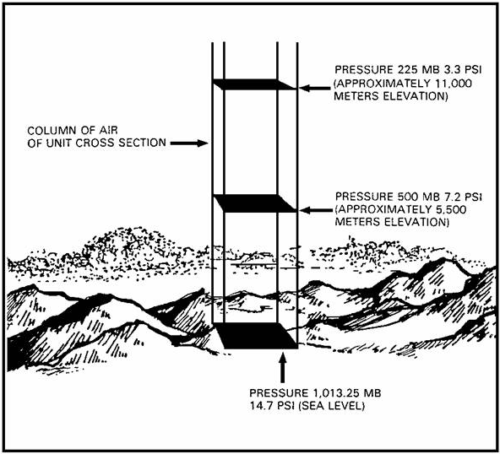

Figure 1. Decrease of atmospheric pressure with an increase in altitude.

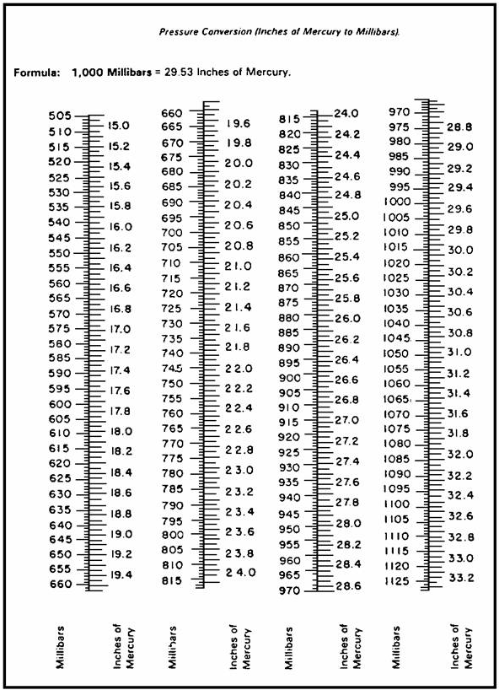

Figure 2. Pressure conversion.

b. Temperature.

(1) Temperature is a measurement of the internal energy of matter.
Matter is made up of tiny particles called molecules. In a solid substance, like a rock, these particles are stuck together and just vibrate around a little. In a liquid, like water, the molecules can slip and slide around each other but still stay together. In a gas, like air, they are free to shoot off in any direction. What all matter has in common is that the molecules move. They have energy that causes the movement. The more energy a substance has, the faster its molecules move. When a fast-moving (very energetic) molecule comes in contact with a slower-moving molecule, it gives part of its energy to the slower-moving molecule. You can liken this to two billiard balls colliding. After the collision, the faster ball moves off more slowly, while the slower one moves away more quickly. This ability to transfer energy is what you are measuring when you measure temperature. Fast-moving molecules have high temperatures, while slow-moving ones have low temperatures. Whenever two substances of different temperatures come together, energy will be transferred from the warmer one to the cooler one. This will continue for as long as they are together or until their temperatures are equal.

(2) Temperature scales. In field artillery meteorology, you will use three temperature scales (Figure 3). They are Fahrenheit (F), Celsius (C), and Kelvin (K). Fahrenheit is the scale with which you are probably most familiar. On it, the freezing point of water is 32º and the boiling point 212º. The
Celsius scale sets freezing at 0º and boiling at 100o. Worldwide, Celsius is the most commonly used temperature scale. On the Kelvin scale, freezing is 273.2º and boiling is 373.2º. It is used in special applications of the science of physics of which ballistic meteorology is a part. The 0º point on the Kelvin scale is where all molecular motion stops. From time to time, it is necessary for you to convert from one scale to another.

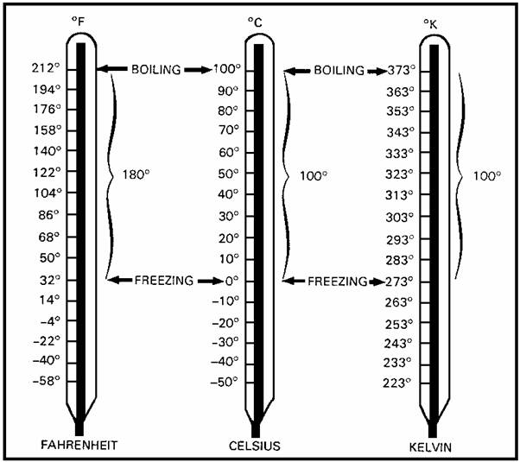

Figure 3. Temperature scales.

- The formula for converting from Fahrenheit to Celsius is:

5
C = - X (ºF - 32º).
9

EXAMPLE: Convert 77º Fahrenheit to Celsius.

5
C = - X (77º - 32º)
9

5
C = - X 45º
9

C = 25º C

Therefore, 77º F equals 25º C.

- For converting from Celsius to Fahrenheit, the formula is:

9
F = (- X ºC) + 32º
5

EXAMPLE: Convert 35º Celsius to Fahrenheit.

9
F = (- X 35º) + 32º
5
F = 63º + 32º

F = 95º

Therefore, 35º C equals 95º F.

- Celsius can be converted to Kelvin by algebraically adding 273.2 to the Celsius value. The primary advantage of the Kelvin scale is that it includes no negative numbers. The formula for converting from Celsius to Kelvin is:

K = ºC + 273.2º

EXAMPLE: Convert 35º Celsius to Kelvin.

K = 35º + 273.2º
K = 308.2º

- To convert ºKelvin to ºCelsius, the formula is:

C = ºK - 273.2º

EXAMPLE: Convert 308.2º Kelvin to Celsius.

C = 308.2º - 273.2º
C = 35º C
Therefore, 35º C equals 308.2º K.

- To convert from Fahrenheit to Kelvin temperatures, you must first convert the Fahrenheit temperature to Celsius.

c. Relative humidity. Relative humidity is a measurement of the amount of water vapor in the air compared to the amount of water vapor the air can hold. It is expressed in percent. At 100 percent relative humidity, the amount of water vapor the air can hold is reached. We say the air is saturated when this occurs. When the relative humidity is 50 percent, the air is holding only half of the water vapor that it can hold.

d. Density. Density is mass per volume. What you are measuring is the combined weight of all the molecules in a given amount of space. In artillery met, we express density as grams per cubic meter. Changes in barometric pressure, temperature, and relative humidity cause changes in density.

e. Virtual temperature. Virtual temperature is the temperature of a parcel of dry air having the same density and pressure as a given parcel of moist air. Virtual temperature is always the same as, or warmer than, the actual temperature. You determine the virtual temperature from a virtual temperature table.

Figure 4 is an extract of the virtual temperature table from FM 6-16-1. The arguments for entry to the table are the air temperature in degrees Celsius and the wet-bulb depression.

EXAMPLE: The dry-bulb reading is 23º C (air temperature) and the wet-bulb reading is 22º C (wet-bulb depression = 23.0º C - 22º C = 1.0º C).

Enter the table with 23º C in the far left column, move right along that line to the wet-bulb depression column 1.0, and read a virtual temperature of 26.0º C.

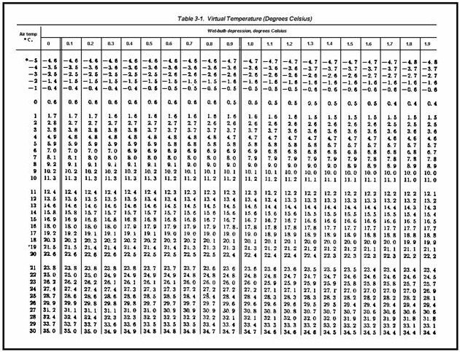

Figure 4. Extract from FM 6-16-1.

f. Wind. Wind is the motion of air relative to the surface of the earth. In artillery met, wind speed is measured in knots. Wind direction is measured in mils and is always expressed as the direction from which the wind is blowing.
Thus, a wind blowing from north to south is called a north wind. Both wind direction and speed may fluctuate drastically with increasing height above the surface of the earth.

3. ATMOSPHERIC STRUCTURE. The atmosphere is divided into several layers
(Figure 5). There are only three layers, troposphere, tropopause, and
stratosphere, that are significant to artillery meteorologists.

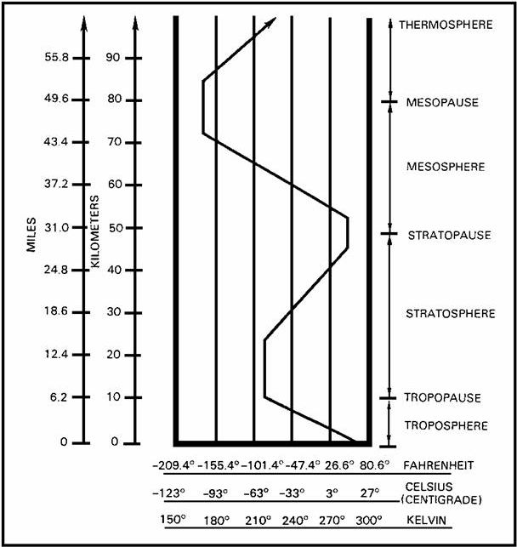

Figure 5. Thermal structure of the atmosphere.

a. Troposphere. The troposphere is the lowest layer of the atmosphere and the only one in contact with the surface of the earth. All weather occurs within the troposphere, because of its closeness to the surface and the presence of water vapor there. It is distinguishable by an average temperature decrease of 6.5º C for every increase of 1,000 meters above the surface in a standard atmosphere. It averages 11,000 meters in thickness, being thicker near the equator and thinner near the poles.

(1) The adiabatic process occurs in the troposphere and causes much of the weather you see. It is caused by decreasing air pressure with increases in altitude. As the pressure decreases, the air molecules spread out more and are not packed as closely together. As they move around, they are less likely to collide with each other and other objects. Therefore, using our definition of temperature, the temperature of the air molecules decreases, because they do not come together as often to transfer energy. The opposite happens closer to the earth.

(2) Weather is produced by uneven heating and cooling of the atmosphere where it comes in contact with the earth. Where it is heated, the air expands and becomes less dense (lighter). Then cooler, more dense air pushes in and displaces the warm air. If the heating continues, this process can result in winds which move vertically as well as horizontally. When the air is moved upward where the adiabatic process can cool it or moved horizontally across another layer of air with a different temperature, clouds and the wide variety of cloud-related weather can result. When cooled, the air becomes denser and sinks. These processes are called convection when the air moves up and down and advection when most of the air movement is horizontal. Each of these processes has its own varieties of clouds and weather.

b. Tropopause.

(1) The tropopause is a narrow transition layer between the troposphere and stratosphere. It is characterized by little or no temperature change with changes in height. It begins at the top of the troposphere and varies between 2,000 and 6,000 meters in thickness. Because of its temperature stability and lack of water vapor, there is no convection and little weather.

(2) Near the tropopause there may be a band of very high winds called the jet stream. The causes of the jet stream are not fully understood. However, it plays a major role in steering weather systems.

c. Stratosphere.

(1) The stratosphere is the highest layer in which military operations are likely to be conducted. High-altitude aircraft and weather balloons are the most frequent visitors to this region. It is a very stable layer. In its lower layers, the temperature changes very little. Then it increases because of the ozone layer. Like the tropopause, there is almost no water vapor and no convection and, thus, no weather. It has effects on the weather in the troposphere, which are not well understood.

(2) The ozone layer is composed of a concentration of ozone molecules, which is a form of oxygen. This layer absorbs ultraviolet radiation from the sun and protects the earth from its harmful effects. The absorption of ultraviolet radiation heats the stratosphere, causing its temperature behavior.

d. Other layers. There are other layers of atmosphere with various physical characteristics. However, they produce no significant weather effects.

4. DEW POINT. The dew point is the temperature at which a parcel of air with a given water vapor content becomes saturated with the water vapor. The ability of air to hold water vapor depends on its temperature. The higher the air temperature, the more water vapor it can hold. The lower the temperature, the less water vapor it can hold. When air is cooled, its ability to hold water vapor decreases. If it continues to cool, it reaches a temperature where the water vapor turns to liquid. This temperature is its dew point. At dew point, water forms on surface objects and fog or clouds are formed. When the dew point is below 0o C, the water vapor condenses as ice crystals.

5. CLOUDS. Clouds are suspensions of microscopic water droplets. They are classified in two ways--how they are formed and how high in the atmosphere they form. See the cloud chart extracted from FM 1-230 (Figure 6).

a. Cumuliform clouds. Cumuliform clouds are formed by convection, or the vertical movement of air. They generally have a cotton-puff-like appearance. Thunderstorms are developed from them. The rising parcel of air is cooled by the adiabatic process, and the cloud forms where the air reaches its dew point.

b. Stratiform clouds. Stratiform clouds are produced by the cooling of a layer of air. This happens when a layer of air moves across a cooler surface or a cooler layer of air. This type of cloud normally occurs as a widespread layer and is relatively thin. Advection, or horizontal air movement, is the main cause.

c. Low clouds. Low clouds are formed within 2,000 meters of the surface.

(1) Cumulus. Cumulus clouds are produced by convection. They appear as cotton-puff-like clouds on a warm summer day.

(2) Cumulonimbus. This is a continued development of a cumulus cloud usually caused by a sudden change in temperature. The convection may be so strong that the cloud grows very large and develops to great heights, sometimes pushing through the tropopause into the stratosphere. It develops a flattened anvil-like top. It produces rain and, frequently, lightning, hail, and tornadoes. The storm that it produces is usually localized and violent.

(3) Stratus. Stratus clouds are layered and produced by advection. They usually cover a wide area and are fairly thin. You can often see the sun through them.

(4) Stratocumulus. Stratocumulus clouds are primarily caused by advection, but there are areas of convective activity. So, these clouds exhibit characteristics of both convective and advective cloud formations. They can produce widespread, heavy rain and conceal cumulonimbus clouds with their violent weather within them.

(5) Nimbostratus. Nimbostratus clouds are a continued development of the stratus cloud. When water vapor is abundant and the cooling action rapid, the stratus cloud becomes thick and condensation occurs quickly enough to produce rain. When this happens, the cloud becomes nimbostratus. The rains produced are usually light and widespread. Violent weather is not associated with this type. The words "nimbo" and "nimbus" mean rain.

d. Middle clouds. Middle clouds appear between 2,000 and 6,000 meters. Their development is similar to the lower cloud forms but usually less prominent.

(1) Altocumulus. Altocumulus clouds are convective and appear like cotton puffs.

(2) Altostratus. Altostratus clouds are formed the same as stratus clouds and, like stratus, can thicken and become nimbostratus, which is the only middle cloud that produces precipitation.

e. High clouds. High clouds occur above 6,000 meters. Unlike their low and middle counterparts, they occur at altitudes where the temperature is always below 0o C. They are made entirely of ice crystals.

(1) Cirrocumulus. Cirrocumulus clouds are cotton-puff-like and convective. There is little water vapor at the high cloud altitudes. This cloud is a good indicator of an unusually large amount of water vapor at these altitudes.

(2) Cirrostratus. A cirrostratus cloud is similar to its lower counter-parts. It usually occurs in extremely thin layers that are sometimes too thin to be seen from the ground.

(3) Cirrus. Cirrus clouds are in a class by themselves. They can form by either convection or advection or both. They appear as feather-like wisps and can thicken into a layer of cirrostratus. Except for their classification as a high cloud, cirrus does not fit into the cumuliform and stratiform categories. None of the high clouds produce precipitation.

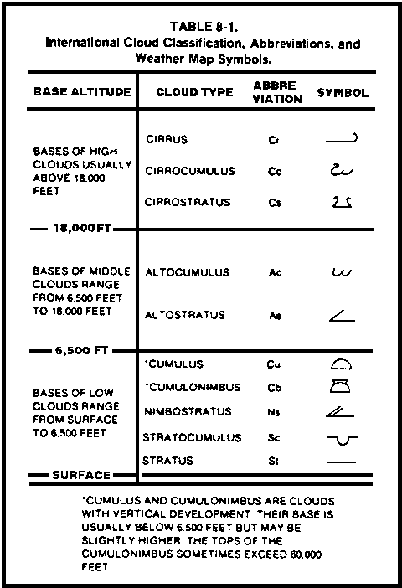

Figure 6. Cloud chart.

6. FRONTAL WEATHER. Fronts are transition zones between large bodies of
air called air masses. These air masses are of different temperatures and relative humidities. The transition zone is narrow, usually only 5 to 80 kilometers thick, because the air masses do not mix readily. On a weather map, the fronts shown are the leading edges of the transition zones where they are touching the surface. The weather along the fronts is called frontal weather. There are many types of frontal weather. The type depends on an unlimited combination of factors, among which are the amount of moisture in the air masses, their stability, their speed of movement, and the slope of the frontal surface. The size and speed with which fronts cause weather changes are major factors in a met section operational schedule. Every type of front may be found along the boundary of an air mass. The east edges have a cold front trailing southward, which becomes stationary along its southern edge. Then, a warm front exists along the air masses western edge. (See Figure 7.)

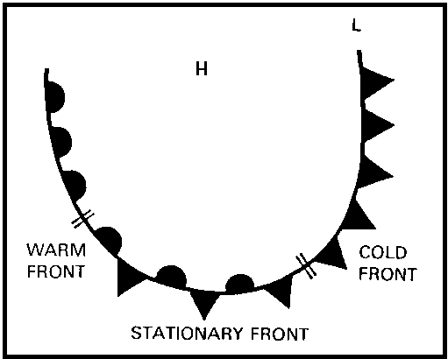

Figure 7. Frontal systems.

a. Cold front. A cold front (Figure 8) occurs when a cold air mass displaces a warmer one on the surface. The speed of movement of the front combined with the stability and moisture content of the warm air mass usually determine the type of weather. A fast-moving cold front moving into warm, unstable, and moist air produces a line of thunderstorms and violent weather just ahead of the front. This line is called a trough. The cold air is actually driving underneath the warm air and pushing it upward in much the same way that convection works, and the result is cumuliform clouds. A slower-moving cold front moving into warm, stable, moist air produces more of an advective effect with its typical stratiform clouds and less violent weather. When both air masses are dry, an abrupt change in wind direction and blowing dust may be all that occurs. When a cold front passes your position, the characteristics are:

- An abrupt or rapid decrease in temperature.

- A sharp wind shift, usually more than 90o.

- A decrease in relative humidity.

- Decreasing barometric pressure as the front approaches, followed by rapidly increasing pressure after it passes.

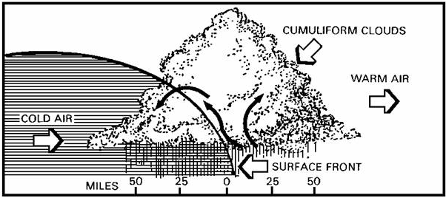

Figure 8. Cold front.

b. Warm front. A warm front (Figure 9) is produced when a warm air mass replaces a cold air mass. The cold air mass is retreating at a slower speed than the warm air is advancing. Because the cold air is more dense than the warm air, the warm air is lifted over the retreating cold air. The frontal slope is very shallow and runs in advance of the surface front. So the predominant clouds are stratiform, widespread in advance of the front, and low clouds. Gentle, soaking rains over a wide area are most commonly associated with warm fronts. If the air masses are dry, there are few, if any, clouds. Warm fronts usually move about half as fast as cold fronts. The main characteristics of a warm front passage are:

- An increase in temperature.

- A slight wind shift, usually less than 90o.

- An increase in air moisture content.

- A decrease in pressure as the front approaches, followed by slowly increasing pressure after it passes.

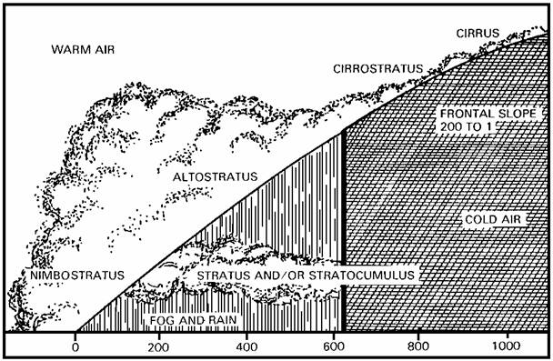

Figure 9. Warm front.

c. Stationary front. Stationary fronts occur whenever a front stops moving or is moving very slowly (less than 5 mph). In general, they resemble warm fronts. However, the weather band can be very active depending upon the frontal slope, the moisture content of the warm air mass, and the speed that the warm air rides up and over the cold air. Both cumuliform and stratiform clouds and their associated weather can be found along the cold side of the front. Stationary fronts are also good areas for the formation of new weather systems and should be watched closely.

d. Occluded fronts. Occluded fronts (Figure 10) are fairly complex
systems involving the interaction of three air masses. Because of the lifting of the warm air mass from the surface, very active convection with cumuliform clouds and violent weather occur along the occlusion. In addition, the warm air aloft still produces warm-front-like weather. So the occlusion can have a very wide weather band. Occlusions produce the most violent frontal weather.

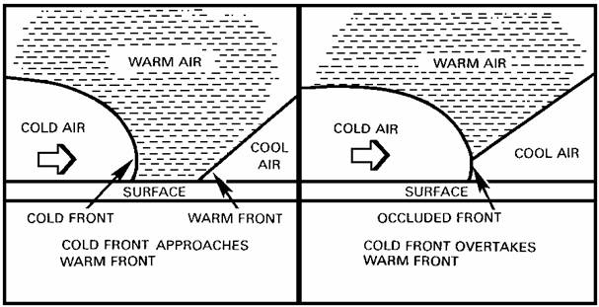

Figure 10. Occluded front.

- Occluded fronts form what is called an open wave. The open wave (Figure 11) usually forms along a stationary front. It begins as a low-pressure area. The counterclockwise circulation around the low-pressure area then starts different parts of the front moving to form warm and cold fronts anchored on the low-pressure center. The cold front usually moves twice as fast as the warm front. If the wave lasts long enough, the cold front overtakes the warm front, producing the occlusion.

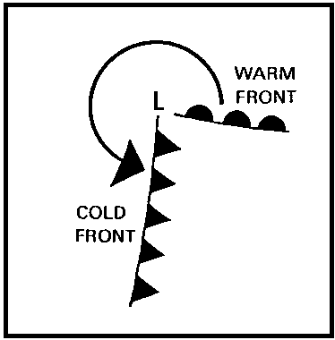

Figure 11. Open wave.

- The warm air is forced up off of the surface, and the rapidly advancing cold air behaves as either a warm front (Figure 12) or a cold front (Figure 13), depending on whether it is comparatively cooler or warmer than the overtaken cold air mass on the surface.

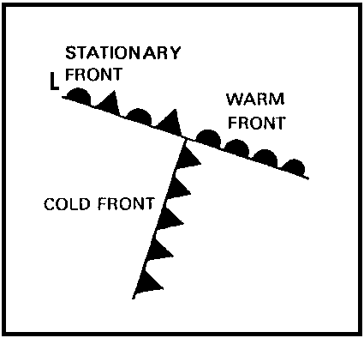

Figure 12. Warm-type occlusion.

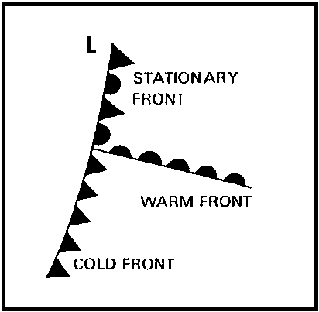

Figure 13. Cold-type occlusion.

7. BALLISTIC QUANTITIES. The field artillery corrects the trajectory of projectiles for weather effects. The quantities that are measured to obtain the data for these corrections are temperature, density, and wind speed and direction.

a. Standard atmosphere. To calculate necessary corrections, the artillery compares the ballistic quantities to a standard set of atmospheric conditions from which tables of firing corrections have been developed. By agreement among the members of the North Atlantic Treaty Organization (NATO), the standard atmospheric conditions determined by the International Civil Aviation Organization (ICAO) are used. The ICAO standard atmospheric conditions for sea level are used as the starting point for computing ballistic corrections (Figure 14). These conditions are:

- Dry air.

- No wind.

- Temperature 15.0º C with a lapse rate in the troposphere of 6.5º C per 1,000 meters.

- Surface pressure 1,013.25 millibars.

- Surface density 1,225 grams per cubic meter (g/m³).

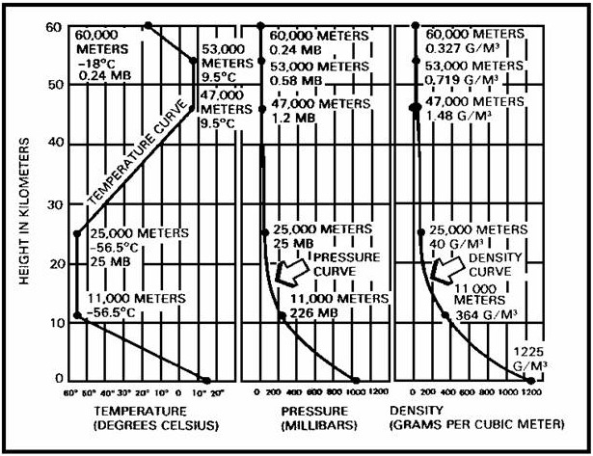

Figure 14. Standard Atmosphere.

b. Ballistic wind. Ballistic wind is a constant wind that produces the same effect upon the trajectory of a projectile as the actual wind encountered in flight.

c. Ballistic density. Ballistic density is a constant density that produces the same effect upon the trajectory of a projectile as the actual density distribution encountered in flight.

d. Ballistic temperature. Ballistic temperature is a single computed virtual temperature that produces the same effect upon the trajectory of a projectile as the actual temperature distribution encountered in flight.

8. BALLISTIC EFFECTS. Ballistic effects, density, temperature, and wind, work together at the same time. They may partially offset each other's effects or increase the total corrections required.

a. Wind. Wind tends to push a projectile. The effect on range and deflection depends on the wind direction relative to the projectile and its speed. The direction effect can be broken down into two components that operate simultaneously .

- Tail or head wind. A tail wind produces an increase in range (Figure 15), while a head wind causes a decrease in range.

- Crosswind. A crosswind deflects a projectile to the right or left of the target (Figure 16).

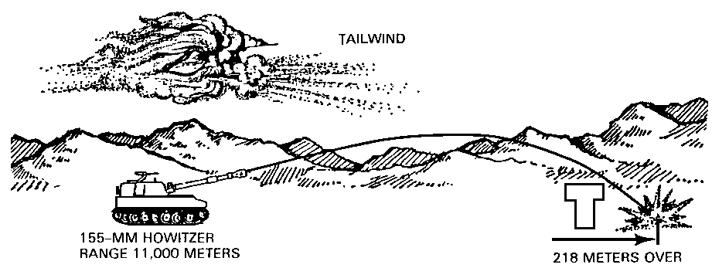

Figure 15. Effect of a tail wind.

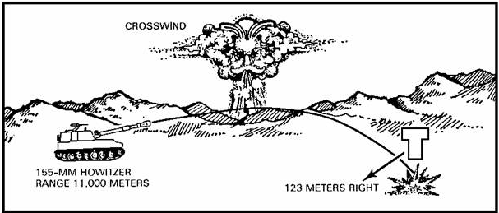

Figure 16. Effect of a crosswind.

Wind speed determines how strongly the wind affects the range and deflection. The greater the speed, the greater the wind effects.

b. Temperature. An increase in air temperature produces an increase In projectile range, because the elastic properties of the air are directly affected by its temperature (Figure 17). Temperature is the smallest of the ballistic corrections.

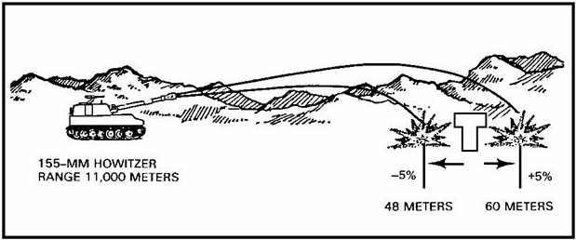

Figure 17. Effect of temperature.

c. Density. Density is the most important artillery weather correction. It can produce the greatest errors in trajectory. Artillery projectiles travel at such high speeds and for such long distances that the air resists their movement and reduces their range. How much resistance is offered depends on air density. Air less dense than standard increases projectile range, and air more dense than standard decreases range. (See Figure 18.)

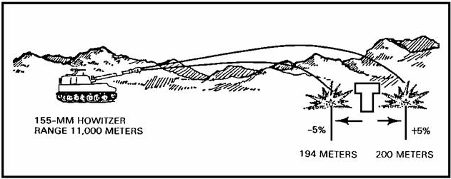

Figure 18. Effect of density.

PRACTICE EXERCISES:

Complete the following exercises by circling T for true or F for false, circling the letter preceding the correct answer, or filling in the blanks, as appropriate. Be sure to complete the practice exercises as they appear. They are "building blocks" and will help you complete the rest of the subcourse successfully. The answers follow the last exercise and are separated by rows of slashes (////).

1. In ballistic meteorology, pressure is measured in ________________.

2. An air pressure of 1,013.25 is equal to how many inches of mercury? (See Figure 2.)

a. 29.52
b. 29.83
c. 29.90
d. 29.92

3. T F Atmospheric pressure may be described as the weight of a
column of air that extends upward to the top of the
atmosphere.

4. Convert the temperature of 25.5º Celsius to Kelvin. ______________

5. Convert the temperature of 255.0º Kelvin to Celsius. _____________
6. Given a dry-bulb temperature of 15.0º C, a wet-bulb temperature of 13.7º C, and Figure 4, what is the virtual temperature?

7. T F Clouds that are formed between 2,000 meters and 6,000 meters are classified as low clouds.

8. The two basic types of clouds are ____________ and ________________.

9. ________________________ is the type of cloud you would most likely see on a hot summer day.

10. Clouds that are formed above 6,000 meters are called ______________ clouds.

11. An occluded front is formed when a __________ __________ __________ __________ __________ __________.

12. A front is more accurately described as an area in which __________
__________ __________ __________ __________ __________ __________.

13. The standard surface pressure that has been adopted by international agreement is ________________ ______________.

14. The three main elements that affect artillery firing are _________, _________ ________, and ________ ________.

15. T F In artillery meteorology, wind speed is measured in miles per hour.

16. An increase in density causes a _________________ in the range of a projectile.

///////////////////////////////////////////////////////////////////////////

ANSWERS:

1. millibars.
2. d.
3. T
4. 298.7º K
5. -18.2º C
6. 16.6º C
7. F
8. cumuliform, stratiform.
9. Cumulus
10. high
11. cold front overtakes a warm front.
12. two or more air masses come together.
13. 1,013.25 millibars.
14. wind, air temperature, air density.
15. F
16. decrease

///////////////////////////////////////////////////////////////////////////

9. SUMMARY. Until now, you may not have considered the impact that weather has upon military operations. A commander who leaves weather out of his plan of operation probably will not complete his mission. Weather not only disrupts troop movement, it also affects artillery fires. You, as a met crew member, are responsible for providing the commander with the weather data necessary for accurate artillery fire.

Lesson 2
ARTILLERY METEOROLOGICAL SECTION

OBJECTIVE

Upon completion of this lesson, you will be able to list the organization, mission, equipment, and employment of the field artillery met section.

REFERENCES

This lesson is based on FM 6-15 and other materials approved for US Army field artillery instruction. However, development and progress render the text continually subject to change. Therefore, base your examination answers on material presented in this lesson rather than on individual or unit experience.

10. INTRODUCTION. The field artillery met section provides valuable weather data to support artillery fires, fallout prediction, Army and Air Force aviation, and specialized weather support within its capabilities.

11. MISSIONS. The mission of the met section is to support the field artillery by providing ballistic, computer, and sound ranging met messages. These messages provide data that are used to calculate met corrections for the firing batteries and for calculating speed of sound by the sound ranging platoons. The mission also includes fallout, air weather service (AWS), and limited surface observation messages. These messages provide weather information to tactical units and support Army and Air Force aviation. They also may be used whole or in part to support other designated activities.

12. ZONE STRUCTURE. The field artillery and activities requiring a fallout message divide the atmosphere into layers. These layers are of different thicknesses according to the type of message produced (Figure 19).

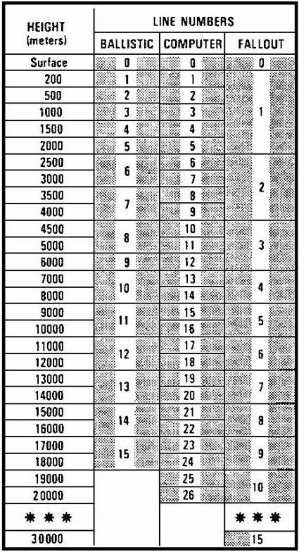

Figure 19. Structure of atmospheric zones.

13. BALLISTIC MET MESSAGE. The ballistic met message is a message that contains information about the current atmospheric conditions of wind, temperature, and density. Each line of the message reports ballistic data for that portion of the atmosphere extending from the surface to the top of the artillery zone corresponding to that particular line number. For example, line 5 of a ballistic message presents ballistic values that represent the atmospheric layer from the surface to the top of zone 5.The zone values for zones 1, 2, 3, 4, and 5 are weighted and added together to determine the ballistic values for line 5.

a. Preparation of the ballistic met message. The procedure for preparing the ballistic met message is divided into three phases--measuring, comparing to standard, and weighting.

(1) Measuring. The average values of wind, density, and temperature for each layer corresponding to standard artillery zones are measured or determined. These values are called zone values.

(2) Comparing to standard. Zone values of temperature and density are compared to the standard conditions for the layer. These comparisons are then expressed as percent of standard.

(3) Weighting. Each zone value of the atmospheric variable is given proportional weight, depending on its influence on the flight of the projectile. The weighting factors differ from zone to zone because the projectile does not spend the same length of time in each zone. The zones are not all the same thickness. After the weighted zone values are summed, the resulting values are called the ballistic values.

b. Ballistic met message form.

(1) DA Form 3675 (Ballistic Met Message) is used by US Army artillery met sections for recording the ballistic met messages. The first four groups of letters and numbers across the top of the message form the heading. Below the heading, the form is divided into six columns--zone height, line number, wind direction, wind speed, air temperature, and air density. Below the ballistic data column, a space is provided for entering the units sending or receiving the message, the time, the date, the message number, the name of the person recording the message, and the name of the person who checked the data for accuracy.

(2) A sample ballistic met message is shown in Figure 20, and the re-cording is explained on the back of DA Form 3675 (Figure 21)

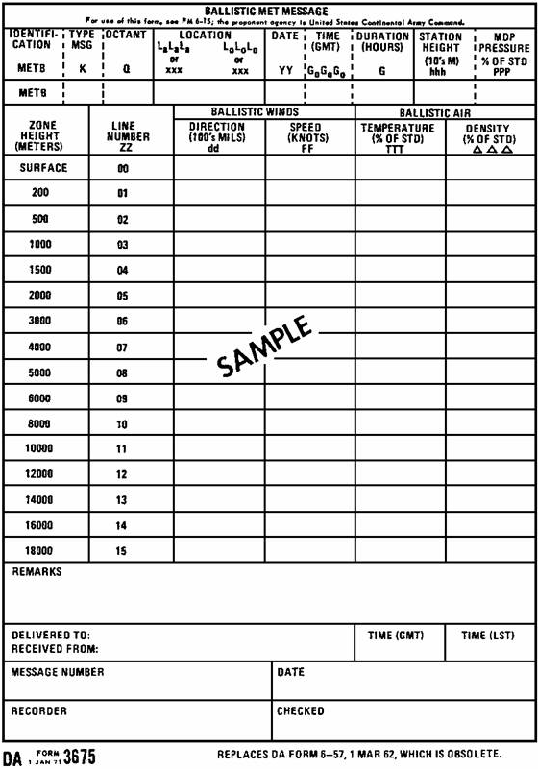

Figure 20. Ballistic met message form (front).

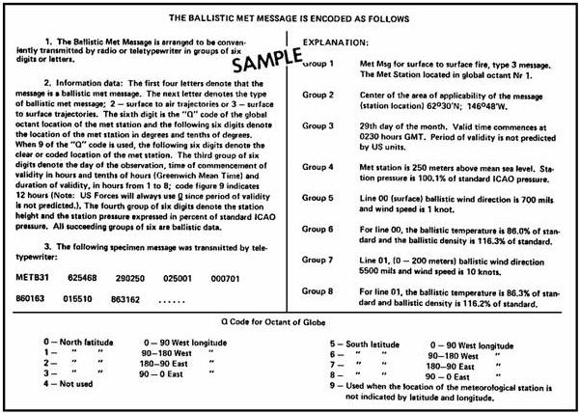

Figure 21. Ballistic met message form (back).

14. COMPUTER MET MESSAGE.

a. The computer met message differs from the ballistic met message in that the zone structure in computer met is not over 1,000 meters in thickness and zone values are not weighted. The weather elements are reported as raw zone quantities. Fire direction center personnel insert the met data into a computer by either the computer keyboard or a punched paper tape. The computer then solves the met portion of the gunnery problem.

b. DA Form 3677 (Computer Met Message) is used by met sections for recording the computer met message. The first four groups of letters and numbers across the top of the form are the heading. Below the heading, the form is divided into six columns--zone height, line number, and zone values of wind direction, wind speed, temperature, and pressure. At the bottom of the form, spaces are provided for entering the units sending or receiving the message, the date and time the message was sent or received, and names of the persons who recorded and checked the message.

c. A sample computer message is shown in Figure 22, and the recording is explained on the back (Figure 23).

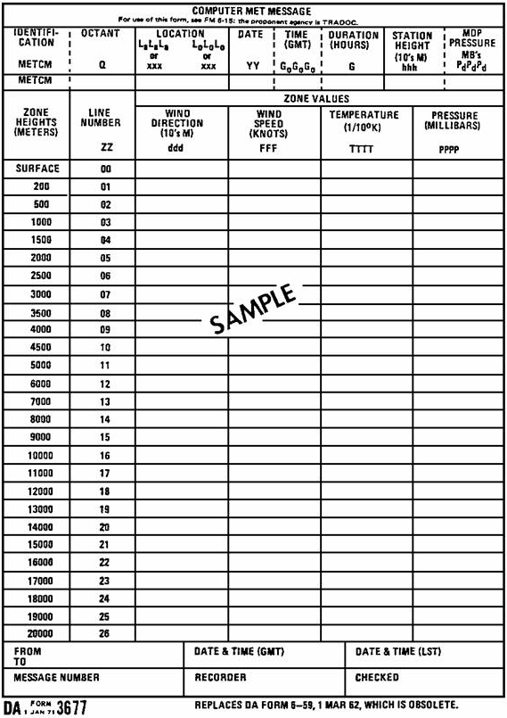

Figure 22. Computer met message form (front).

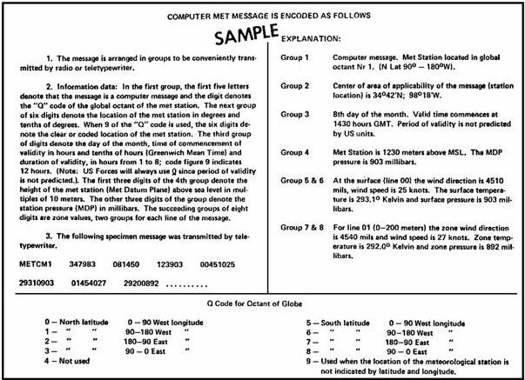

Figure 23. Computer met message form (back).

15. SOUND RANGING MET MESSAGE. Sound ranging is a method of locating a sound source, such as the firing of a weapon or the burst of a projectile, through computations that depend on the sound wave produced. The speed of sound is not a fixed value but varies with the existing atmospheric conditions. Existing atmospheric conditions are measured, plotted, weighted, and disseminated to the sound platoon of the division artillery target acquisition battery. Corrections are applied to the measured sound ranging data to compensate for the variations of the atmospheric conditions from standard.

16. MET SECTION ORGANIZATION.

a. Division. The field artillery ballistic met section is part of the headquarters and headquarters battery (HHB) of each division artillery.

b. Field artillery brigade (group). The field artillery (FA) ballistic met section is part of the HHB of each FA brigade (group). The met section mission, capabilities, and organization are identical to those of the division artillery met section.

c. Separate brigade. A met section is required in the HHB of the direct support battalion assigned to each brigade. The primary mission of this met section is to support the brigade when it is operating independently. The section mission, equipment, and personnel are the same as those of the division artillery met section.

d. Division artillery. The division artillery met section is composed of 1 warrant officer and 10 enlisted personnel, as follows:

DUTY POSITION MOS GRADE

Ballistic met technician 201A WO
Met section chief 93F40 E7 (NCO)
Met crew member 93F30 E6 (NCO)
Met crew member 93F20 E5
Met crew member/mechanic 93F20H1 E5
Met crew member 93F10 E4
Met crew member 93F10 E4
Met crew member 93F10 E4
Met crew member 93F10 E3
Met crew member 93F10 E3
Met crew member 93F10 E3

17. MET SECTION EQUIPMENT. The artillery met section can determine met data by two methods--electronic and visual. The electronic method is the primary method, and the visual is the secondary. The electronic method uses the rawinsonde system to determine current atmospheric data from which the met messages are made. The major components of the system are shown in Figure 24.

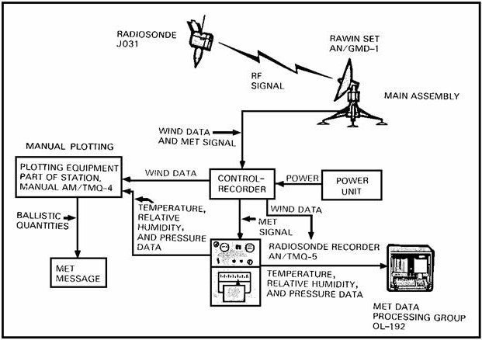

Figure 24. Equipment of the rawinsonde system.

a. Radiosonde J031. The radiosonde J031 (Figure 25) is a balloonborne, battery-powered miniature weather station that automatically transmits pressure, temperature, and relative humidity data. Its radio transmitter limits its range to altitudes of approximately 30,000 meters and distances of about 200 kilometers from the receiver in the rawin set. The radiosonde consists of two major assemblies--the modulator and the transmitter.

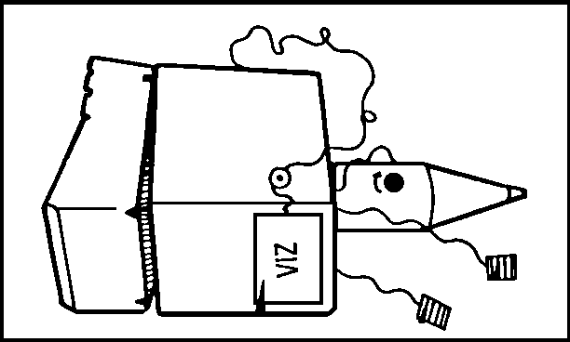

Figure 25. Radiosonde JO31

(1) The modulator group is located in a white plastic box. The modulator consists of three major components--the temperature measuring element, humidity measuring element, and pressure measuring element.

- The temperature element is a small ceramic-type resistor coated with white lead carbonate pigment. Its range of measurement is from +60º to -90º C.

- The humidity element is a strip of polystyrene plastic, fitted with two metal electrodes along the edges and coated with a moisture-sensitive film. It can measure from 10 percent to 100 percent relative humidity.

- The pressure unit is the heart of the modulator, since it activates all of the electrical weather measuring circuits. It consists of an aneroid pressure cell that expands as the atmospheric pressure decreases causing the linkage and lever system to be activated.

(2) The transmitter of the radiosonde is housed in the cylindrical
plastic container. It consists of the necessary circuit components to produce an ultrahigh frequency (UHF) radio signal in the range of 1660 to 1700 megahertz
(MHz).

b. Rawin set AN/GMD-l(*). The rawin set AN/GMD-l(*) (Figure 26) is a
transportable radio direction finder and met data processing electronic computer. This equipment electronically tracks a balloonborne radiosonde throughout its flight, measures azimuth and elevation angles to the radiosonde, and receives the radio signals containing the temperature, pressure, and humidity data. The set consists of a main assembly, a control-recorder, a met data processing group, and accessories.

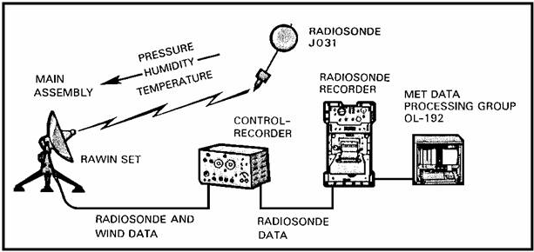

Figure 26. Rawinsonde System.

- The main assembly is a directional radio antenna with automatic tracking capability. It receives and amplifies the radiosonde radio signal and generates a set of azimuth and elevation angles that correspond to the radiosonde position.

- The control-recorder receives the met data signal from the main assembly and relays it to the radiosonde recorder. It also serves as an electrical junction box for the set power and records the azimuth and elevation angles.

- The met data processing group OL-192 (Figure 27) consists of a portable electronic computer and a paper tape reader-perforator mounted in a common case. It evaluates met data and produces the met messages and a teletype tape to aid transmission of the data.

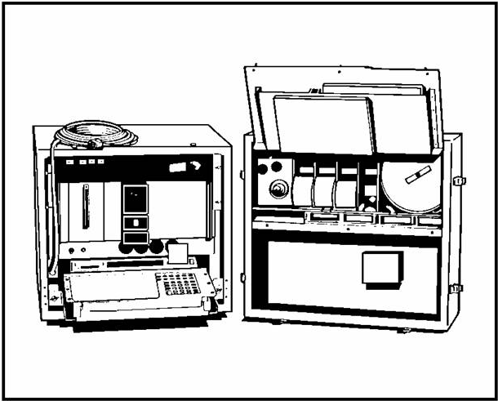

Figure 27. Met data processing group OL-192.

c. Radiosonde recorder AN/TMQ-5. The radiosonde recorder (Figure 28)
receives the temperature, pressure, and relative humidity and records them in
graphic form on a chart. The data may then be analyzed and entered into the
OL-192 for evaluation.

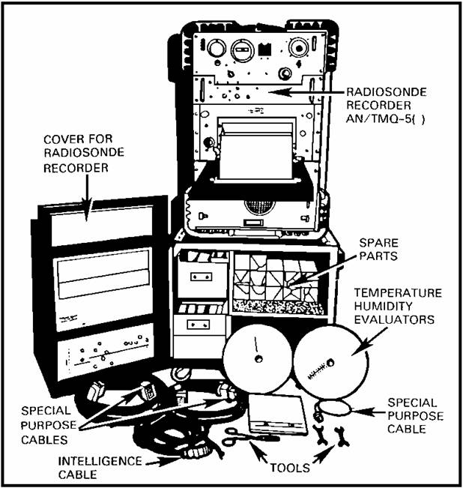

Figure 28. Radiosonde recorder AN/TMQ-5.

18. CAPABILITIES OF THE ELECTRONIC SECTION.

a. Artillery met sections can sound the atmosphere to heights of 30,000
meters, day or night, and in all types of weather except severe surface winds.
These sections are mobile. Their mobility is compatible with that of a division
artillery headquarters command post. The section normally carries a 7-day
supply of expendables and spare parts. Sections can sound the atmosphere
approximately every 2 hours. A limiting factor is the time required for a
sounding balloon to reach a required height. Where high-altitude soundings and
several types of messages are required, met sections can sound the atmosphere
only every 4 hours. A met section in position can produce a ballistic message
for light artillery 30 minutes after the release of the balloon. The maximum time required to produce a maximum height fallout message is about 2 hours.

b. When enough electric power is not available or operational
considerations require it, upper winds data are acquired by visually tracking a
pilot balloon (pibal) with a theodolite (Figures 29 and 30). The data can be
worked either manually or, if power is available, entered into the OL-192 to be
processed.

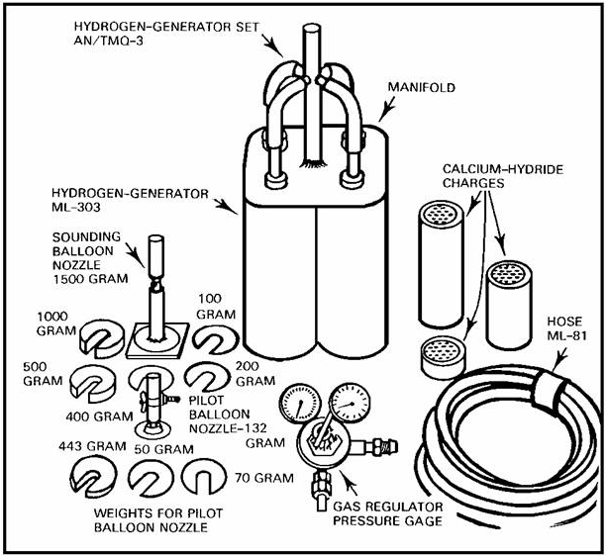

Figure 29. Balloon inflation equipment.

Figure 30. Theodolite.

19. EMPLOYMENT OF MET SECTIONS.

a. The primary consideration in the employment of met sections is deter-
mining where they can best provide support to the firing units. The farther
from the projectile trajectory the met data are measured, the less representative they will be of the atmosphere the projectile actually encounters. Sections should be well forward and within a command post area where communications facilities are available. Prevailing winds, terrain, and logistical requirements are also considered in met site selection. Normally, met sections are positioned with their respective units. However, if coverage is not adequate in a corps area, the target acquisition officer in the corps field artillery section may recommend position changes to the corps fire support coordinator/corps artillery commander. Because of the vast number of variables involved, it is impossible to state with any degree of confidence that a met message is valid for a specific radius from the met station. However, studies addressing met message validity have established guidelines; that is, distances for average weather situations. They are:

- In rolling to level terrain, data from met sections up to 20 kilometers from the trajectory midpoint are acceptable.

- In mountainous regions, along coastal areas, and along shorelines of large bodies of water, met measurements vary significantly over relatively short distances. Met message validity is reduced proportionately to the inconsistency of the terrain.

b. The passage of time decreases the accuracy of a met message because
of the changing nature of the weather. With the present equipment, it is ex-
tremely difficult for the artillery met section to provide met messages more
frequently than 2 hours over an extended period of time. There are no specific
rules for determining the usable time, since that determination depends on the
characteristics of the atmosphere, periods of transition, met section movement,
personnel, supplies, equipment, and number of lines of the met message re-
quired. When the weather pattern is variable, the usable time is variable. If a frontal passage is forecast for the area, the met section will prepare a new met message after the front passes.

- Figure 31 depicts a flight schedule that is based on the changing summer temperature-density profile in a stable atmosphere. Flights are taken at intervals of less than 2 hours when temperature changes of 5º F or more occur. This generally occurs from 1 ^{1/2} hours after sunrise through a 3- to 4-hour time span and is caused by the transition of night (cold) to day (warm).

- Daytime schedules should anticipate the temperature changes as the atmosphere gains most of its heat. Stable temperatures are normal through the afternoon; thus, soundings can be less frequent.

- As sunset approaches, the changing temperature must be monitored. Schedules may have to be adjusted to less than 2 hours as the atmosphere cools. About 2 hours after sunset, the cooling stabilizes to less than 5º F change per hour.

- During night and early morning hours, the atmosphere has reached maximum cooling and becomes stabilized. Therefore, flight schedules could be taken at times that exceed 2-hour intervals.

- This schedule is based on one set of sunrise/sunset times and one weather pattern. Tactical situations and the immediate need of the field artillery must be the primary factors that dictate met schedules.

- This figure portrays minimum met flight requirements that are based on a temperature profile when temperature changes in excess of 5º F per hour are caused by heating and cooling of the earth. Additional soundings are required by abrupt changes in wind speeds and/or directions caused by frontal activity.

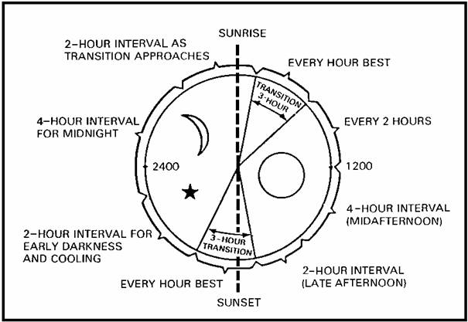

Figure 31. Frequency of met messages.

PRACTICE EXERCISES:

17. What units are authorized a field artillery met section?

________________________________________________________
________________________________________________________
________________________________________________________

18. How many enlisted personnel make up a met section?

a. 9
b. 10
c. 11
d. 13

19. The mission of the field artillery met section in support of the field
artillery is to provide __________ __________ __________ __________
__________ __________.

20. The mission of the artillery met section also includes __________,
_________, and __________ __________ __________ messages.

21. T F On a ballistic met message, all zones are the same thickness.

22. After the weighted zone values are summed, the resulting value is
called a __________ __________.

23. On a ballistic met message form 3675, ballistic temperature is encoded
as--

a. degrees Celsius.
b. percent of standard.
c. degrees Kelvin.
d. degrees Fahrenheit.

24. The primary method of determining met data is __________.

25. The radiosonde transmits radio signals relating to __________,
__________, and __________ __________.

26. The radiosonde J031 consists of __________ major assemblies.

27. The range of measurement of the temperature element is from __________
Celsius to __________ Celsius.

28. The range of measurement of the humidity element is from
percent to __________ percent.

29. The electronic apparatus that measures the angular direction to the
radiosonde is the--

a. modulator.
b. rawin set.
c. theodolite.
d. radiosonde.

30. What is the primary consideration in the employment of a met section?

///////////////////////////////////////////////////////////////////////////////

ANSWERS:

17. each division artillery, field artillery brigade (group), and direct
support battalion of a separate brigade
18. b.
19. three basic types of met messages.
20. fallout, AWS, limited surface observation
21. F
22. ballistic value.
23. b.
24. electronic.
25. pressure, temperature, relative humidity.
26. two
27. +60º, -90º
28. 10, 100
29. b.
30. Determining where they can best provide support to the firing units

/////////////////////////////////////////////////////////////////////////////

20. SUMMARY. For a firing battery to complete its primary mission of putting
rounds on a target, the met section must satisfy the requirements of its primary
mission. To do this, the data contained in the met message must be accurate,
timely, and complete. If the met message is not accurate, timely, and complete,
the primary mission is not met.

